|  |  |  |
| --- | --- | --- |
| **Students Details** | HNDSE 24.2 F |  |
| **Module Name:** | Robotics Application Development |
| **Module Lecturer/Course Coordinator:** | Mr. R G V Pathirana |
| **Department:** | School of Computing | |
| **Submission Due on:** | 10th of March 2025 | |
| **Type of Coursework:** | Group | |
| **Title of the Coursework:** | Implementing an Automated Robot (02nd Progression) -  Group 24 | |

***Student Details:***

|  |  |  |
| --- | --- | --- |
|  | **Student No.** | **Student Name** |
| **01** | COHNDSE242F- 042 | Azward M A |
| **02** | COHNDSE242F- 041 | Ilma M H F |
| **03** | COHNDSE242F- 063 | Iroshan S G H |

|  |
| --- |
| **Office use only :** |
| Date Stamp Required of the Department |

**NATIONAL INSTITUTE OF BUSINESS MANAGEMENT**

**HIGHER NATIONAL DIPLOMA IN SOFTWARE ENGINEERING**

**COURSEWORK**

**Robotics Application Development**

**Pet Robot (Final Progression) – Group 24**

**SUBMITTED BY**

|  |  |
| --- | --- |
| COHNDSE242F- 042 | Azward M A |
| COHNDSE242F- 041 | Ilma M H F |
| COHNDSE242F- 063 | Iroshan S G H |
|  |  |

**Date of Submission:** 10th of March 2025

Contents

1. Problem Definition 4

2. Researching and Designing 5

2.1 Researching 5

2.2 Designing 7

3. Build the Robot (BOM) 9

4. Programming (Flow Chart) 11

5. Circuit Diagram (Simulation) 12

6. Evaluating the robot 13

6.1 Results of the operation 13

6.2 Limitation 13

6.3 Recommendation 14

7. Timeline 15

# Problem Definition

The proposed robotics application is a smart pet robot with following functions.

* Performs rotating, moving forwards and backward, tilting the head, wagging the tail
* Follows the user
* Emits sounds when the smoke is detected as a security function
* Avoids obstacles
* Respond to touch inputs – To toggle to obstacle avoid and user follow mode
* LED bulb lights up corresponding to background darkness automatically

The above-mentioned functions are planned to control using commands given through a laptop. All the commands are controlled using Bluetooth control system. The purpose of implementing a pet robot is to replicate the traditional pet with an automated pet to provide the owner with companionship, entertainment and convenience with certain limitations. With the busy life cycle of the current population, their need is to minimize their workload and maintain their mental fitness. Therefore, the proposed pet robot will be suitable for the current generation as it reduces the maintenance cost and time for a traditional pet as it is automated, only needs a repair if any technical issues were met and it helps to enhance the mental well-being of an individual as well.

Basic requirements which are expected from the pet robot is to perform following activities.

* Perform functions mentioned in above
* Detecting obstacles and avoiding
* Identifying the background darkness

As per the above problem definition, the proposed pet robot will assist the user with its owned functions to replace a traditional pet with a robot instead.

# Researching and Designing

## Researching

According to the proposed robot, the focus of the implementation is given to its movements and functions performed. The following electronic components are needed to build the pet robot to function as expected.

1. Motors

* **Servo Motors** Facilitates implementing movement processes such as tilting the head, wagging the tail.
* DC Motors used to make the robot move front, backwards and rotate.

1. Sensors

* **Infrared sensors** are used to prevent the robot from hitting obstacles as it detects the object.
* **Ultrasonic sensor** is used to place the object away from the obstacle with a fixed distance because it can measure the amplitude between itself and the obstacle.
* **Gas sensor** is used to detect smoke level of the environment.
* **Touch sensor** is used to detect physical touches and respond reactions.
* **LDR sensor** is used to detect the background’s brightness/darkness.

1. Arduino Board

* Considered as the brain of the robot as it is responsible for grabbing the inputs and controlling output using selected components.

1. Breadboard

* Used to connect components together in the circuit.

1. LED bulbs

* Used to light up the neck belt.

1. Lithium-Ion battery

* It is the power source for robots.

1. Buzzers

* This component is used to get audio output from the robot

1. Wires and Connectors

* Used to connect each component together.

1. DC Motor Controller

* Used to controller the speed and direction of the motor

1. Chassis

* The base structure which holds all the components of the robot.

1. Resistors

* Used to control the flow of electricity.

1. Bluetooth Module

* Used to control some functions of the robot wirelessly.

Apart from the above devices more tools and materials are needed to design the external appearance and fix the model as designed. Those will be mentioned in the fourth chapter.

## Designing

Following is a sketch of the pet robot to display where the certain components are added.

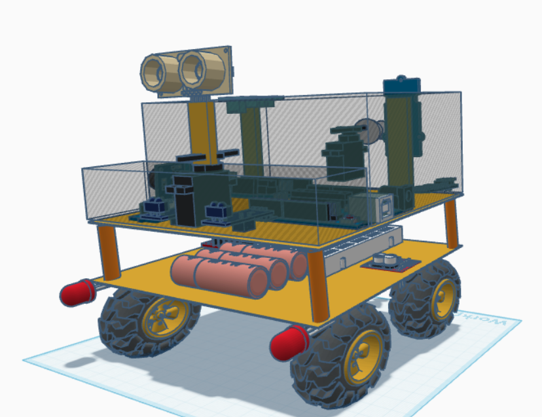

# Build the Robot (BOM)

To build the robot, the following tools, components and equipment are needed. They are listed as a bill of materials (BOM).

|  |  |  |  |
| --- | --- | --- | --- |
| **Component** | **Quantity** | **Amount (Rs)** | **Total(Rs)** |
| Chassis | 01 | 1760 | 1760 |
| Servo Motors | 02 | 390 | 780 |
| IR Sensor | 02 | 110 | 220 |
| Ultra-Sonic Sensor | 01 | 250 | 250 |
| LDR Module | 01 | 260 | 260 |
| LED Bulbs | 04 | 20 | 80 |
| Arduino Uno | 02 | 2600 | 5200 |
| Jumper Cables (male to male) | 03 pack | 260 | 780 |
| Jumper Cables (female to female) | 02 pack | 260 | 520 |
| Jumper Cables (male to female) | 01 pack | 270 | 270 |
| Lithium-Ion battery (3700mah) | 03 | 780 | 2340 |
| 18650 battery charger | 01 | 590 | 590 |
| 9v battery | 01 | 200 | 200 |
| Motor driver | 01 | 490 | 490 |
| Buzzers | 01 | 40 | 40 |
| Touch Sensor | 01 | 160 | 160 |
| Gas Sensor | 01 | 350 | 350 |
| Breadboard | 01 | 290 | 290 |
| Bluetooth Module | 01 | 990 | 990 |
| Charging case | 01 | 100 | 100 |
| Buck convertor | 01 | 580 | 580 |
| Glue Sticks | 06 | 40 | 240 |
| Glue Gun | 01 | 720 | 720 |
| Soldering Iron | 01 | 700 | 700 |
| Soldering Wire | 01 role | 120 | 120 |
| Soldering Iron Stand | 01 | 490 | 490 |
| Scissor | 01 | 150 | 150 |
| Glue (normal) | 01 | 115 | 115 |
| Super Glue | 01 | 95 | 95 |
| Paper Cutter | 01 | 200 | 200 |
| Double Tape | 01 | 750 | 750 |
| Plier | 01 | 1470 | 1470 |
| Resistors | 01 pack | 50 | 50 |
| Other |  | 500 | 500 |

|  |  |  |  |
| --- | --- | --- | --- |
| **Total Amount** |  |  | **Rs 21850.00** |

# Programming (Flow Chart)

According to the proposed project, the process of the robot can be displayed using a flow chart as follows.

# Circuit Diagram (Simulation)

Overall Design

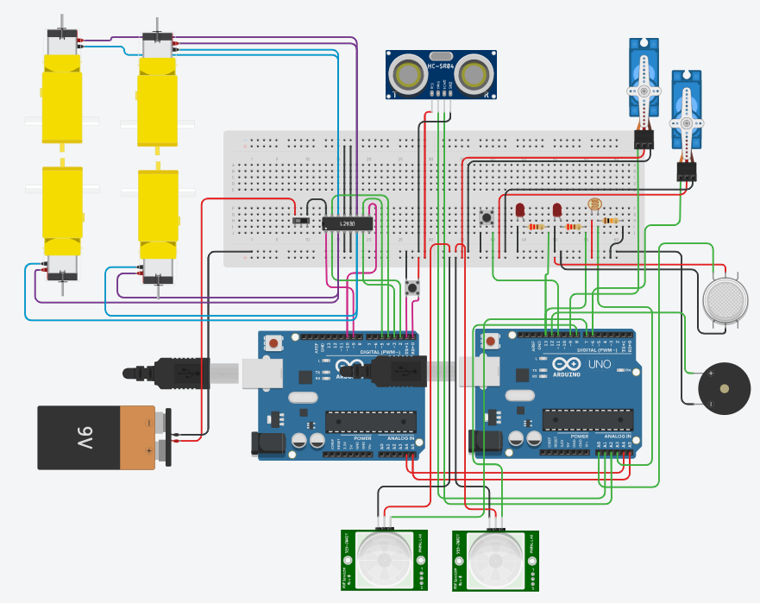

# Evaluating the robot

# 6.1 Results of the operation

Once the robot is implemented and ready to use, the robot will work according to Bluetooth control. When the robot is powered by using the switch, it works according to user commands (manual mode).

The user can command the robot using a mobile phone as a Bluetooth controller to perform All the actions such as, moving forwards, backward, left, and right, switching to obstacle and user follow mode. Robot uses IR and Ultrasonic sensor in user following mode on the other hand it uses only Ultrasonic sensor in obstacle avoiding mode. When the user presses the touch sensor the pet robot will wag the tail.

Gas sensor has been used to detect smoke and emits a sound from buzzer to notify the user and the robot has a LDR module to detect the brightness level and light up the LEDs during the dark.

## 6.2 Limitation

As for the limitations of the project, the following can be considered.

* Some output and action errors may occur as the sensors may not work perfectly due to environmental changes.
* The robot will only trigger relevant user commands because it is designed to perform only certain tasks.
* Hardware may wear out with time and regular maintenance and fixes are required.
* The initial cost for implementing a robot is high.
* Battery life will be stored for a small time period, and it is needed to recharge.
* Limited storage of certain components cannot store large amounts of data.
* The robot cannot locomote across uneven surfaces smoothly.
* High and low temperatures will affect certain functionalities of components.
* Overtime usage may heat the system and cause failures

## 6.3 Recommendation

As the future recommendations,

* Artificial intelligence can be applied to identify environmental changes and advance performance
* Can implement the robot to understand and identify selected users voice and emotions to provide more likely pet feeling using biometric sensors.
* Allow to respond to virtual assistants such as Alexa
* Implement data security measures.
* Enhance the design which is eco-friendly to prevent harm to environment.

In conclusion, the proposed project will act as a pet instead of a traditional pet in order to the need of owner for their ease of use.

# Timeline

|  |  |  |  |  |  |  |  |  |  |  |  |  |
| --- | --- | --- | --- | --- | --- | --- | --- | --- | --- | --- | --- | --- |
| Phases | Week 01 | Week 02 | Week 03 | Week 04 | Week 05 | Week 06 | Week 07 | Week 08 | Week 09 | Week 10 | Week 11 | Week 12 |
| Define the objectives |  |  |  |  |  |  |  |  |  |  |  |  |
| Research and Feasibility Study |  |  |  |  |  |  |  |  |  |  |  |  |
| Design and Planning |  |  |  |  |  |  |  |  |  |  |  |  |
| Prototyping the Hardware |  |  |  |  |  |  |  |  |  |  |  |  |
| Coding the robot |  |  |  |  |  |  |  |  |  |  |  |  |
| Testing the functions |  |  |  |  |  |  |  |  |  |  |  |  |
| Debugging the errors |  |  |  |  |  |  |  |  |  |  |  |  |

1. Define the objectives

Find out a problem statement by researching a problem in the society and create a solution through a robot.

1. Research and Feasibility Study

Research about the relevant hardware components to implement the robot.

1. Concept Design and Planning

Gathering all those hardware components and make the connection in between them.

1. Prototyping the Hardware

Creating an outer cover with relevant hardware components to depict the shape of a pet with additional hardware components and connections.

1. Coding the robot

Choosing a programming platform and program the robot according to needed functions.

1. Testing the functions

Run the robot and identify its errors and areas to improve.

1. Debugging the errors

Debug and modify the robot with relevant modifications.